Need help?
HCSD Parent Center Clothing Closet
601-574-2771
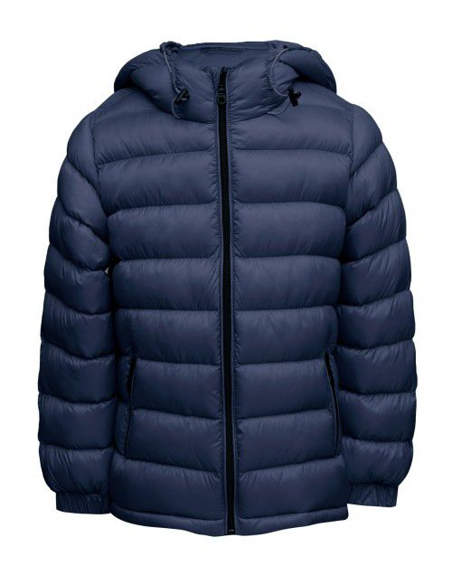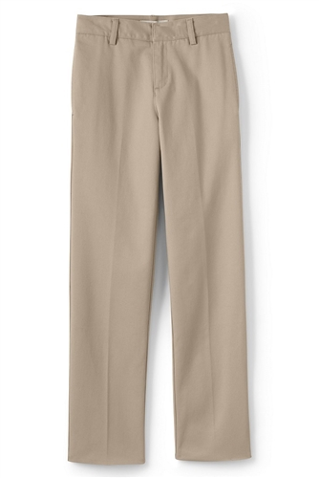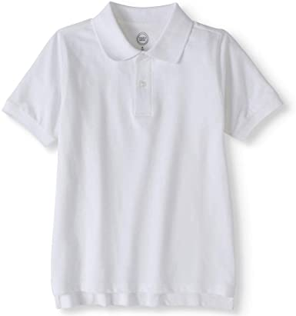
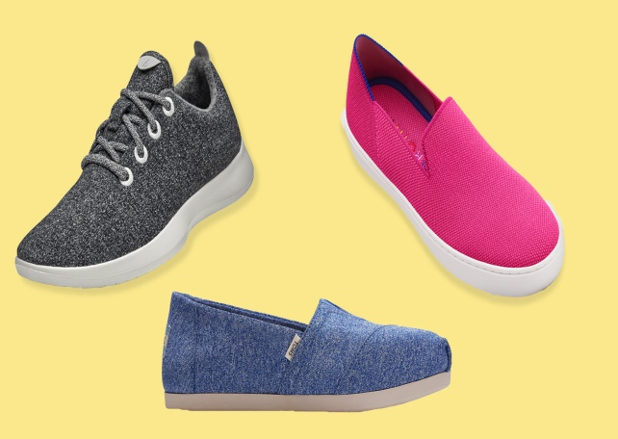
Contact: Pamela Seaton/Parent Liaison
Location: Parent Center (Middle School)
7:30-4:30(Monday, Wednesday, Friday)
8:30-5:30(Tuesday, Thursday)
(Also accepting donations)

